**PROJECT DEVELOPMENT PHASE DELIVERY OF SPRINT-2**

|  |  |
| --- | --- |
| Team ID | PNT2022TMID38117 |
| Project Name | Retail Store Stock Inventory Analytics |

**PROJECT DEVELOPMENT PHASE:**

**Sprint-1:**

**Sprint-2:**

* Data Collection
* Data Preparation
* Data Exploration

**Sprint-3:**

**Sprint-4:**

* Dashboard Creation
  + Report Creation
  + Story Creation

# SPRINT-2:

## DATA EXPLORATION

* LOAD THE DATASET
* SALES ANALYSIS
* PRICE ANALYSIS
* STOCK AND PRICE FOR YEAR COLORED BY PRICE
* PRICE FOR YEAR COLORED BY YEAR
* STOCK AND SALES FOR YEAR COLORED BY YEAR
* YEAR COLORED BY YEAR SIZED BY STOCK
* STOCK TREE SUNBURST
* SALES TO PRICE WITH LINE WIDTH PRICE
* STOCK USERS
* YEAR SIZED BY SALES
* PREPARED DATA LINK

# DATA COLLECTION:

Download the Dataset

Dataset link - https://drive.google.com/drive/folders/1kiL- 5CHJmQvbk9VyFsuUs-myAupBZGNy

**LOAD THE DATASET:**

Tool used – IBM Cognos

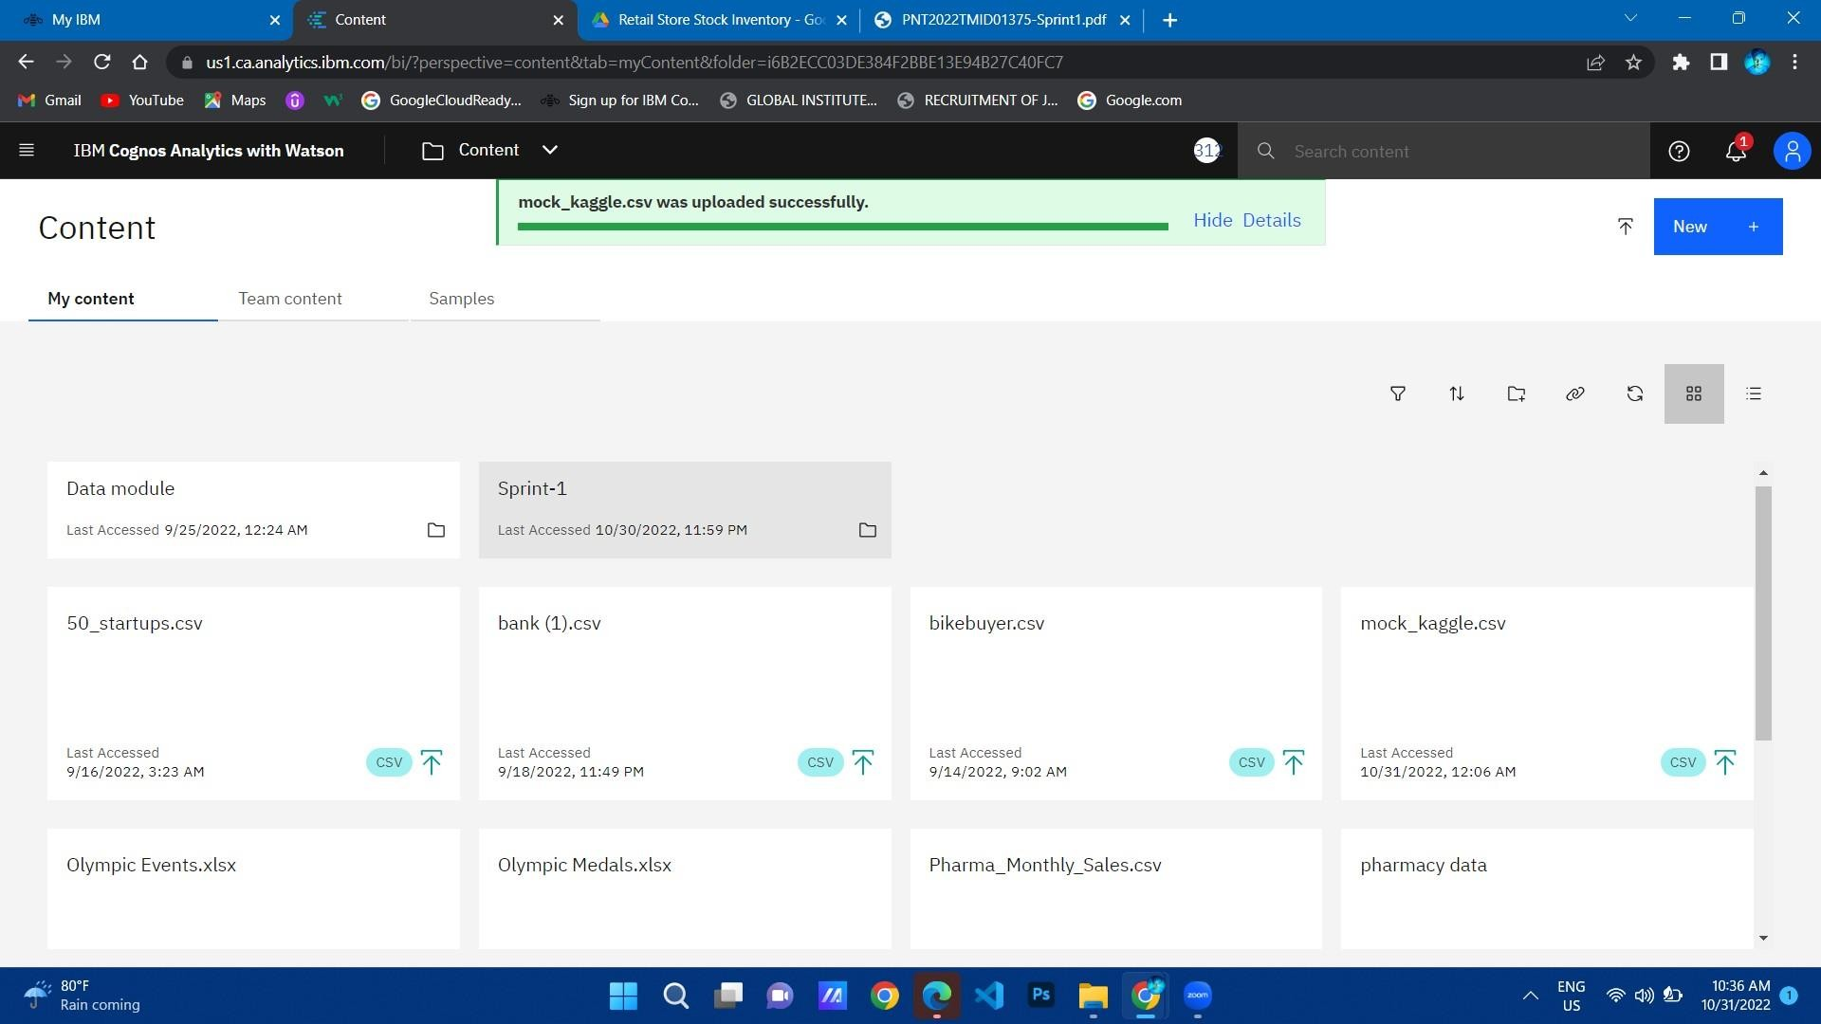

SALES ANALYSIS:

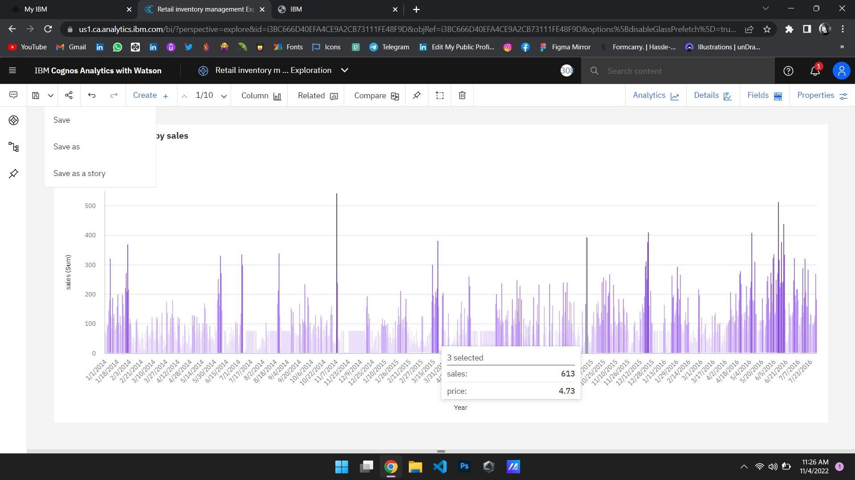

**PRICE ANALYSIS:**

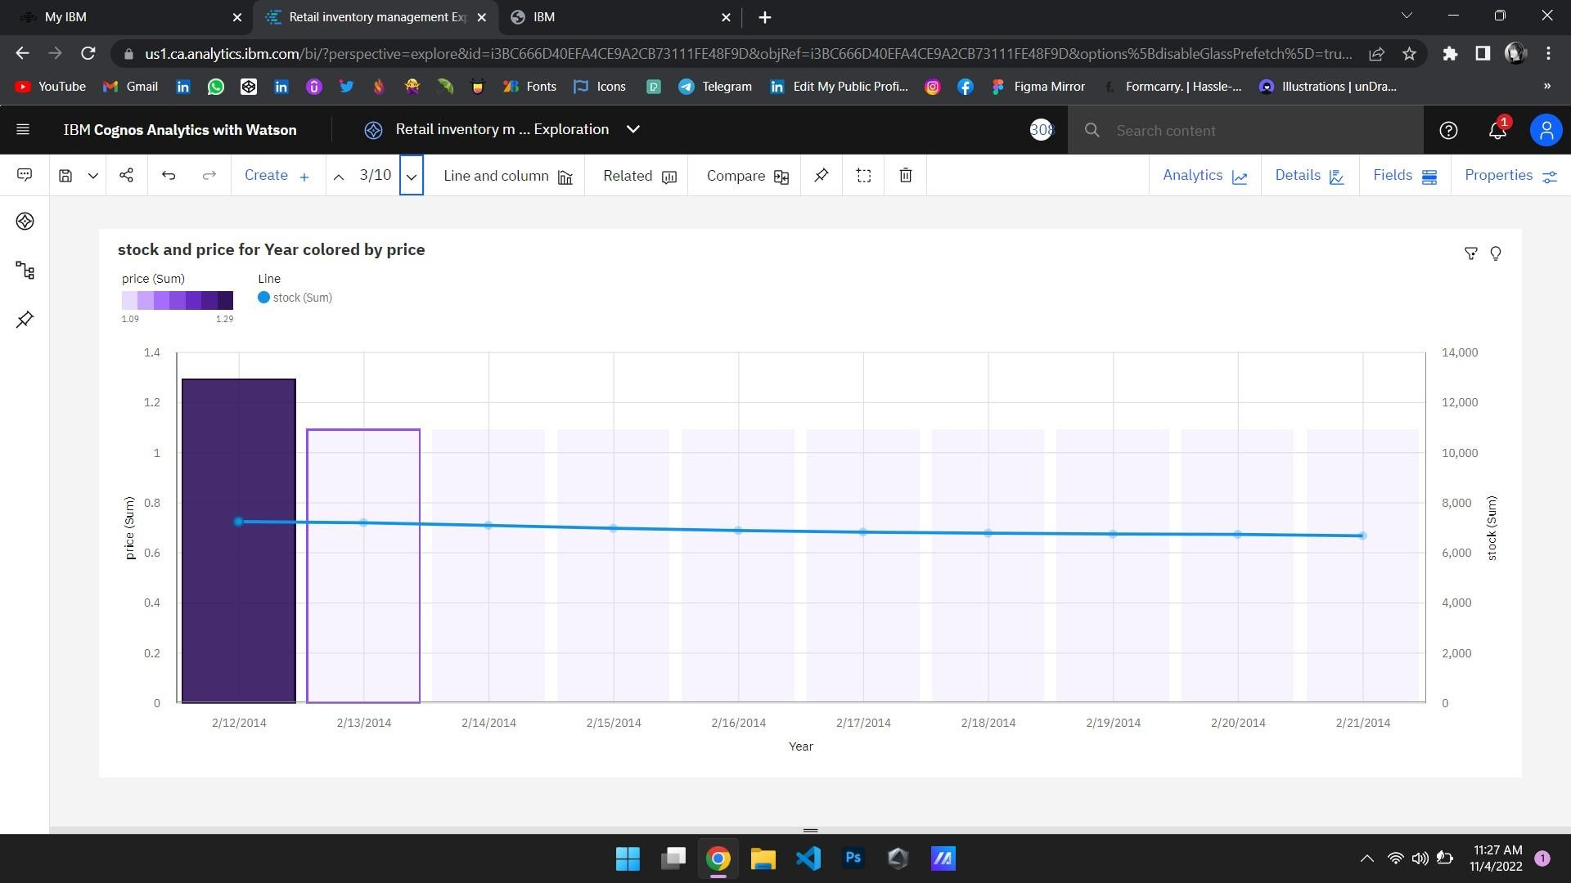

**STOCK AND PRICE FOR YEAR COLORED BY PRICE:**

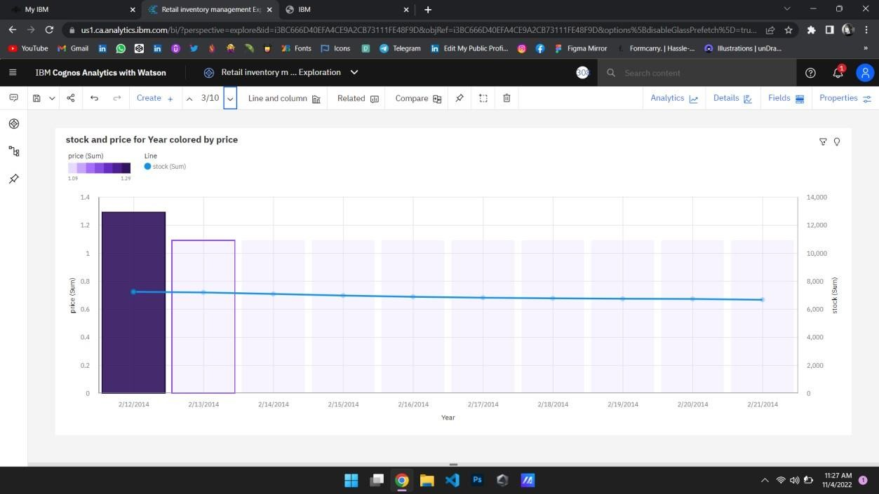

**PRICE FOR YEAR COLORED BY YEAR:**

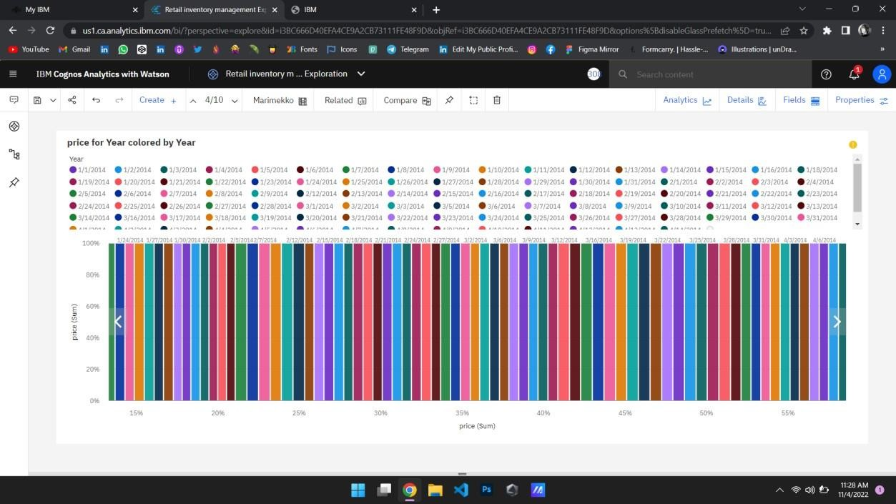

**STOCK AND SALES FOR YEAR COLORED BY YEAR:**

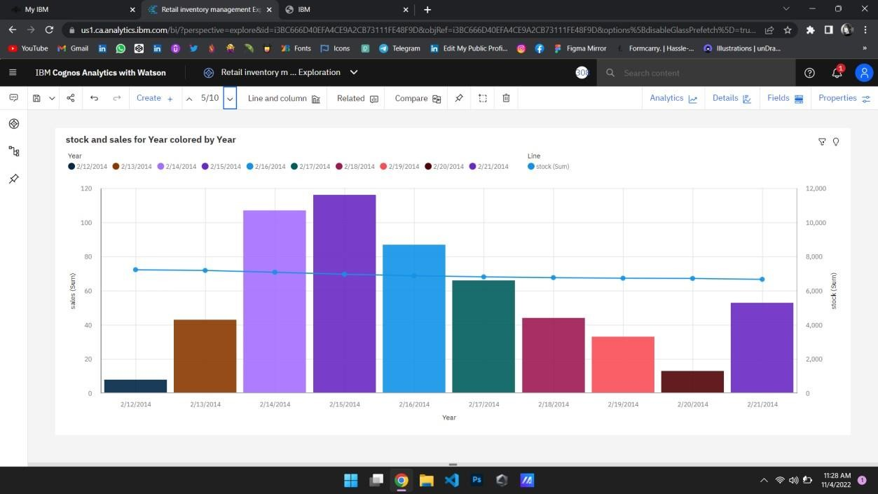

**YEAR COLORED BY YEAR SIZED BY STOCK:**

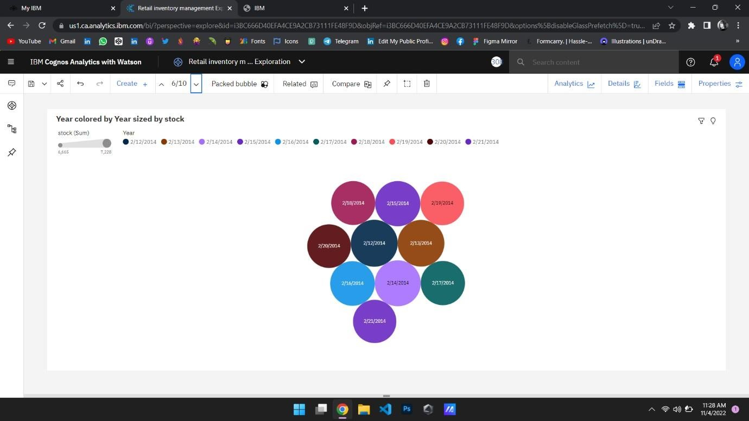

**STOCK TREE SUNBURST:**

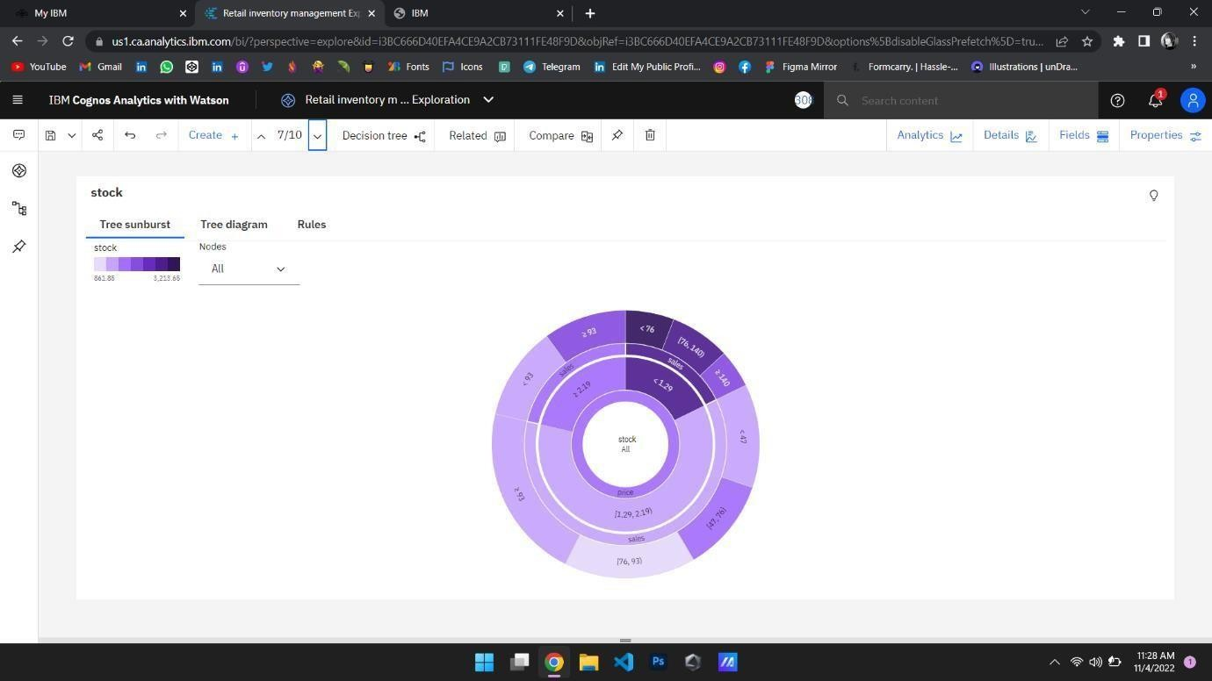

**SALES TO PRICE WITH LINE WIDTH PRICE:**

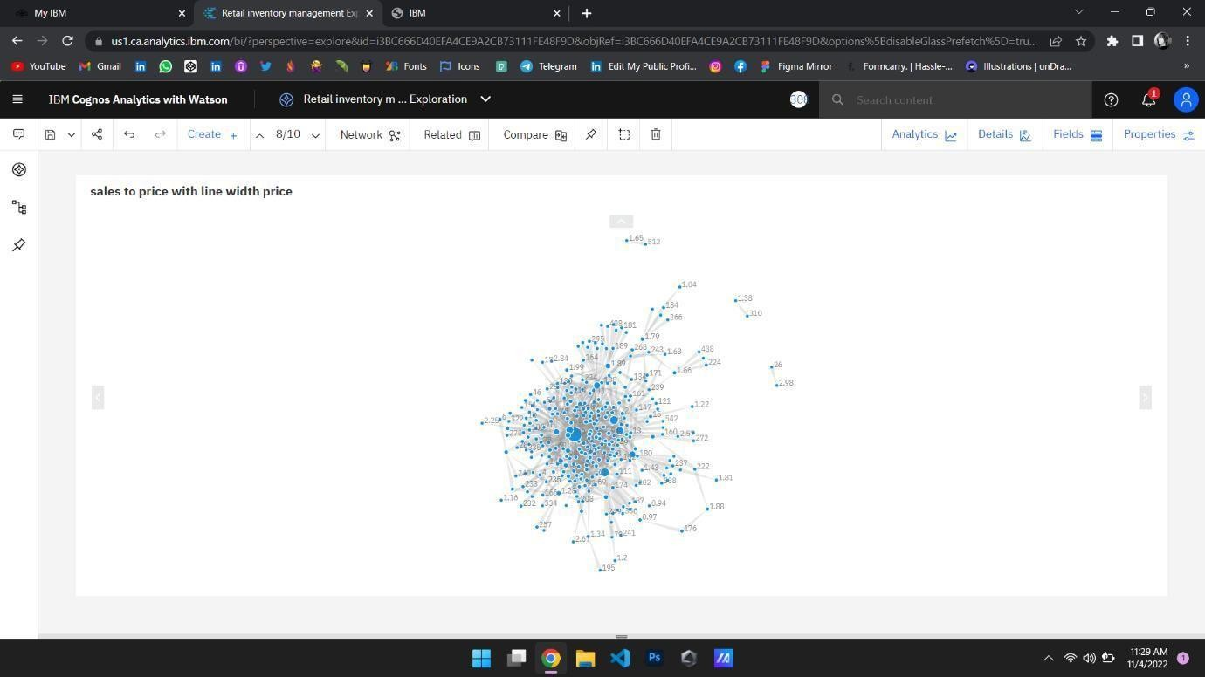

**STOCK USERS:**

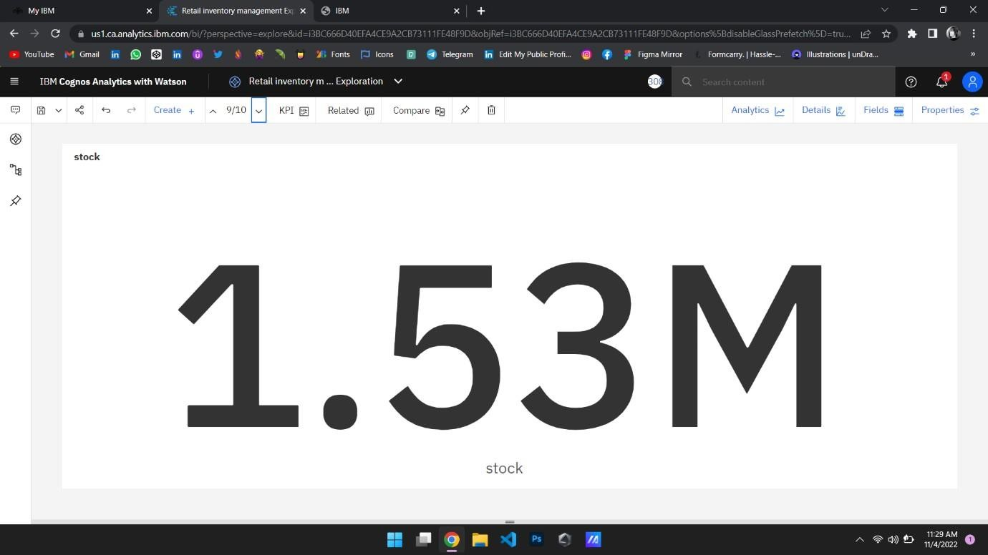

**YEAR SIZED BY SALES:**

